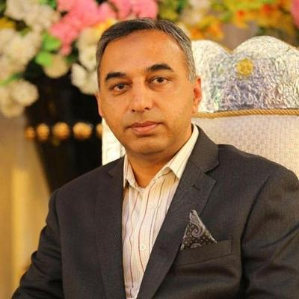
SHAHBAZ GHANI  PHONE NO :03015606731 WhatsApp No: 03015606731 Email Address:  shahbazghani04@yahoo.com  EDUCATION  PAF SCHOOL  AIR BASE INTER COLLEGE SARGODHA(MARTIC AND FSC)  BE MECHANICAL ENGINEERING IN NUST EME COLLEGE AND UET LAHORE  MS VEHICLE ENGINEERING  BEIJING CHINA  Awards and Achievements:  Hobbies:  INTERNSHIP Experience: | PROJECTS:  Skills  Technical Skills:  1:ENGINNERING MANAGEMENT  2:ASSEMBLY AND DESSEMBLY ENGINE PARTS  SOFT SKILLS:  Communication, Interpersonal, Leadership Skills Problem-Solving Skills  MILITARY COURSES:  1:  MILITARY AWARDS AND ACHIVEMENTS  1:  JOB Experience:  32 YEARS OF ENGINEERING AND ALSO TEACHING EXPERIENCE AT NUST EME COLLEGE.

